Moter bike analysis

**1.get data**

Select * from bike

**2.manufacturing year group by quantity_sold in asc**

select manufacturing_year,count (quantity_sold) as total_sales

from mbike group by manufacturing_year

order by manufacturing_year asc

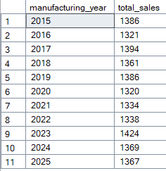

**3. brand wise group by total_profits in desc**

select brand,sum (profit) as total_profits from mbike

group by brand order by brand desc

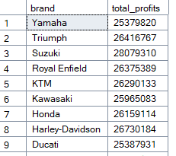

**4.category wise group by profit in desc**

select category,sum (profit) as total_profit from mbike

group by category order by total_profit desc

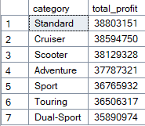

**5.manufacturing_year wise group by profit in desc**

select manufacturing_year,sum (profit) as total_profit

from mbike group by manufacturing_year

order by manufacturing_year desc

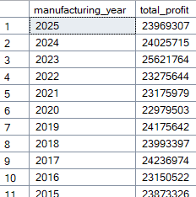

**6.total sum of tatal profit**

select sum(total_profit) as review from mbike



**7 brand wise group by rating in asc with avg**

select brand,avg(rating) as trating from mbike

group by brand order by trating asc

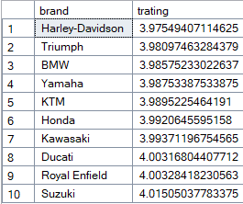

**8.manufacturing-year wise group by rating in asc**

select manufacturing_year,avg (rating) as t_rating from

mbike group by manufacturing_year order by t_rating asc

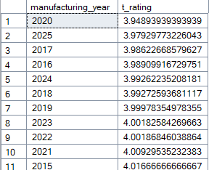

**9.category wise group by rating in asc with avg**

select category,avg (rating) as arating from mbike

group by category order by arating asc

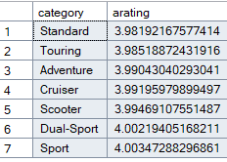

**10.category wise group by quantity_sold in desc with sum**

select category,sum (quantity_sold) as t_sold from mbike

group by category order by t_sold desc

